**“Store Management System”**

Synopsis submitted to the IIMT College of Engineering,Greater Noida in partial

fulfillment of the requirements for the award of the Degree of

**B.Tech**

**In**

**(Information Technology)**

**By**

*Richa Gupta 1902160130039 4th year*

Full time

Under the guidance of

Ms. Laveena Sehgal

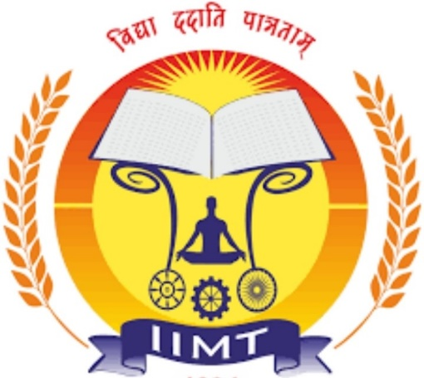

IIMT COLLEGE OF ENGINEERING, GR. NOIDA

(Department of Information Technology)

*(SESSION:2022-23)*